Michael Almdal Scholarship Fund
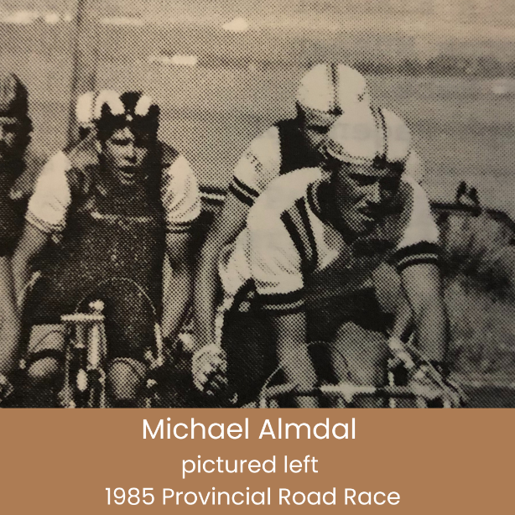
Michael Almdal, one of Alberta’s premier cyclists, was fatally injured while training for the Provincial Road Race Championships on August 24, 1990 at the age of 22. In his first season of racing, 1985, Michael placed third as a junior in the Provincial Road Race Championships. He twice competed in Quebec’s Tour de l’Abitibi, where in his second year he finished 15th. He won the senior (Cat 1) Provincial Road Race in 1987 and 1988 and then went on to compete in the Olympic Trials in Vancouver. His ultimate goal was to compete in the Tour de France.

“Biker Mike” was one of the few athletes able to attend university full-time and train for cycling full-time. He had just completed his 2nd year of engineering at the University of Calgary. He brought the same discipline and intensity to his studies as he did to his racing.

His memory lives on through a Memorial Scholarship Fund and the annual awarding of the Michael W. Almdal Memorial Cup. Michael’s family and friends established the Fund in 1990 to commemorate his athletic and academic accomplishments.

The fund will provide a $3000 scholarship to an accomplished Alberta licensed cyclist attending an accredited college or university on a full-time basis. The successful student will receive $1500 per semester. If you are interested in applying for the Michael Almdal Scholarship Fund please reply with an expression of interest, your current academic situation and future goals.

Please complete your submission by September 15th and email or scan the completed form on page 2, as well as a cover letter and return to info@albertabicycle.ab.ca

Name:
Address:
License number: |  |  |  |  |  | Telephone No.
Birth Date: |  |  |  |  |  | Cycling Club:
Racing Discipline(s): ________________________ Racing Category(ies): ______________________

Name and Telephone number(s) of person(s) who coached you and/or introduced you to
cycling:
Name and Telephone number(s) of at least one other reference:

Your achievements in the past season (please feel free to attach another page if needed):
(a) Cycling (Please include the category you raced in):
(b) Other:
Your goals for the coming season:
(a)Cycling:
(b) Other:
Signature of Applicant:
Date:

