Platinum Racing, in cahoots with Peloton Racing p/b Momentum Cycling present…
Alberta’s most grueling race of truth!
Saturday, June 15th, Calgary, AB

Special thanks to our sponsors for making event as awesome as possible:
Proudly Supporting:

Sanctioned by:

Overview

On June 15th, 2019, prepare to race the clock at Alberta’s longest individual time trial. And in classic Alberta form, we’re gonna make it tough as hell!
In combination with the Chinook Classic Triathlon Festival and the Chinook Classic Gran Fondo, Granary Road will play host to the finish celebration, which you will be praying for in this challenging and beautiful point to point course, nestled in the foothills of Cowboy Country!

Race Organizers
Tom Bamford
Chief Sweat Officer, Platinum Racing
tom@platinumracing.ca

Reinier Paauwe
President, Peloton Racing
reinier.paauwe@gmail.com

Registration

Registration available online at Zone4.ca
Deadline for registration will be Thursday, June 13th, 2019 at 11:59 PM.
Late registration will not be accepted.

All riders contesting the event must have a valid ABA or UCI road license. Single event licenses will be available for this event.
All of the non-ABA members have to sign a waiver at sign on and race Cat 5.

Categories

The following provincial categories will be offered:
Men Women
Category 1/2 Category 1/2/3
Category 3 Category 4/5
Category 4
Category 5
Para Para
Junior Junior
Citizen Men Citizen Women

License Check, Bike Check & Race Number Placement
License check will be held at the Granary Road Market starting at 8:00 a.m. Saturday, June 15th, 2019. Riders must present their license to the Technical Delegate before racing or will be ineligible to race. Single day licenses are available at time of registration.
Bike Check – Bikes and equipment will be checked for conformity to the UCI Regulations prior to each rider’s start. Please arrive 15 minutes prior to your start for bike check.
One race number is required for the time trial. The number must be placed low on the centre of the back and pinned vertically (see figure below). Numbers cannot be folded or otherwise modified. Frame plates are not required.
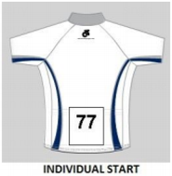

Course Description

The 2019 Chinook Classic ITT is a 34 km individual time trial held on the rolling roads of Rocky View county, on the south edge of Calgary. The roads are narrow but are in excellent condition and traffic is light. The center line is marked and turns will be marshaled for auto traffic and coned. Please do not cut to the inside of the cones on turns. Be prepared for some serious climbs, with over 600m elevation!

Parking is available at Granary Road market.
The start area is approximately 9km from the parking and finish area, located at the corner of Spruce Meadows Downs Way and 194th Ave SW. The finish is at Granary Road market.
Please use caution riding to the start and allow sufficient time to arrive prior to your start time.

Course Information

Distance | 34km ITT Course Notes
0 | Start SB on 64 Street W and 242 Ave
1.6 | Turn left on 242 Ave W
5 | Turn right on 32 Street W
14.5 | Turn right on Highway 549
22.7 | Turn right on 112 Street W
33.6 | Finish in front of Granary Road Market.

Course Map and Profile
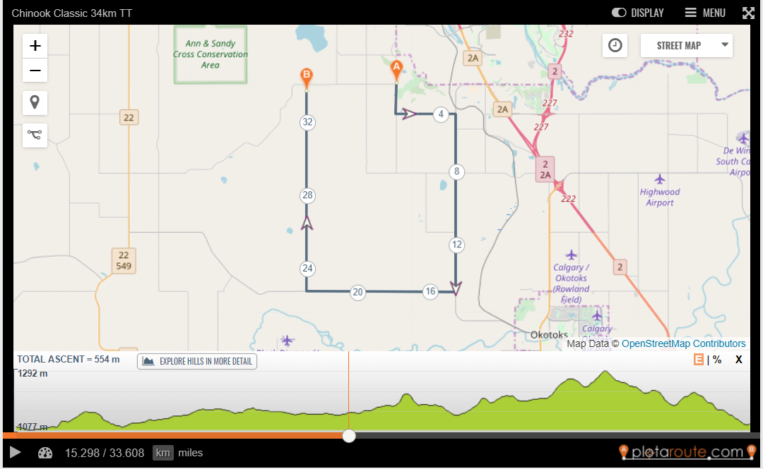

Estimated Start Times

First riders will set off at 8:30am, and there will be 1 minute in between riders.
Approximate start times will be provided closer to race date.

Awards and Post-Race Celebration

Granary Road market will host the finish celebrations and beer garden.

Results will be posted at the sign on area. Podiums will take place at immediately after conclusion of the event at the sign on area. AB Cup Series points and upgrade points will be awarded according to the ABA Points schedule B (20, 15, 12, 10, 8, 6, 4, 2).

Rules and Regulations

Rules & Regulations UCI/CCC/ABA regulations will apply. Riders are responsible to read & understand these. They can be found here. Receiving permission to host road events is becoming extremely challenging; only through preparing and submitting for approval. Further the ABA and race organizer are committed to providing a safe environment for all participants. It is therefore of the utmost importance that you adhere to the rules and regulations. Please understand that your cooperation is essential to ensure that this event will be safe and fair for all participants.

Traffic & Parking

You are riding on OPEN ROAD. Please be aware of traffic and remember all riders are subject to the center line rule. Marshal flagmen will stop traffic at intersections. That said, it is the rider’s responsibility to ensure he or she is safe.
There will be lots of parking available at Granary Road.

Rider Conduct

Unsportsmanlike conduct will not be tolerated, including but not limited to public urination, littering, use of profane language and verbal abuse of officials. Bottles and trash are not to be discarded. Fines may be issued if this is not followed.

Washrooms

Washroom facilities are available at Granary Road market. Please use the washroom facilities. Riders may be penalized for improper behavior.

First Aid

Emergency first aid will be on hand at the event. 911 service is available at the race site. The nearest hospital is South Calgary Health Centre, at 31 Sun Park Plaza SW. Distance is 16 km.
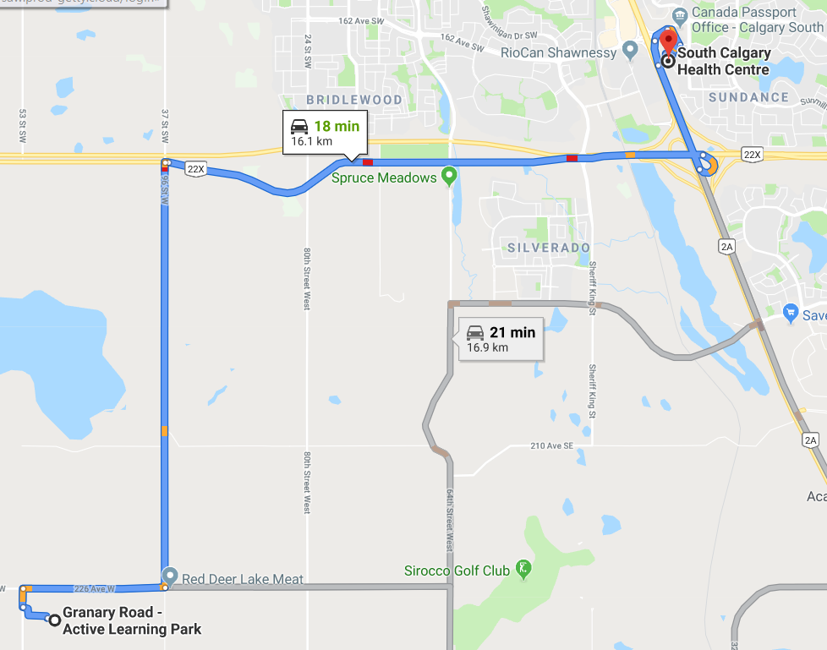

Directions to Granary Road Public Market

From Edmonton

From Downtown Calgary

